**Monday 4th April 2022**

Dear Parents and Carers,

We have some very exciting news to announce to you. We will have a new member of staff joining our team at The Priors School after the Easter holidays to lead on wellbeing and pastoral care. We are delighted to introduce to you to Penny!

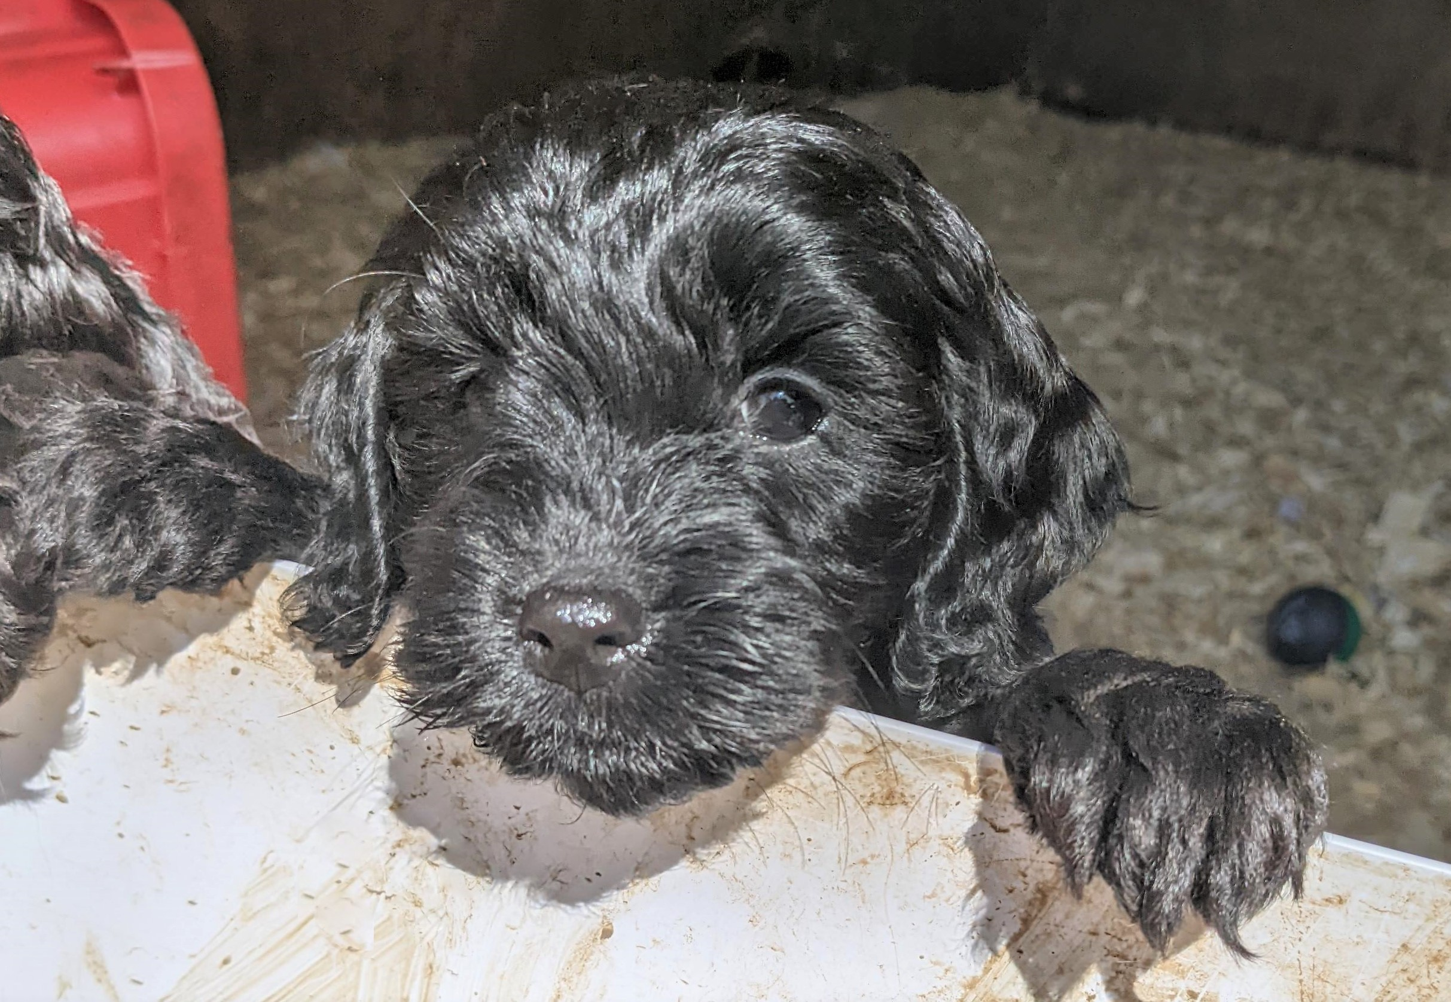

Penny is a cockapoo puppy who will be coming to work at The Priors School as a school dog. Penny’s eventual roles and responsibilities will be:

* Learning with the children;
* Working with individuals;
* Supporting children with wellbeing and pastoral issues;
* Be a reward for children; and
* Teach children about responsibility, empathy and caring for others.

We have been working hard in the background on researching the benefits of a school dog and how to introduce a dog to school for a number of years now (since 2016 to be precise!) and we really believe that she will be a valued member of the team. The research shows that there are numerous benefits to dogs being in school such as: increasing school attendance, improving children’s confidence, decreasing learner anxiety and improving learning outcomes – especially in reading. After this thorough research, we decided that it would be a good decision for the children of The Priors School.

It is really important to stress that Penny will be Mr Emms’ family pet, but will come into work every single day. Before she can work with the children, she will need lots and lots of training. During the first year of her life, we will be getting Penny used to the sights, sounds and smells of The Priors School and socialising her so that she is calm when she is in the building. She will go to obedience classes on a weekly basis and needs to achieve the Kennel Club Good Citizen Dog Training Scheme Silver Certificate. Once she has achieved this level of obedience, we will work with other organisations to teach the staff how to handle her and use her with the children. Until this point, Penny will spend most of her time in the school office and will meet the children on a very limited basis. This will also give us time to teach the children about how they work with her and about dog body language.

We know that some children are not comfortable around dogs and no child will work with Penny if they do not want to. We will be sending a permission slip home in the near future so that you can decide if you want your child to work with her. We are also aware that some children have pet fur allergies. We have chosen a cockapoo as they are generally hypoallergenic and are low fur shedders, so this should generally mean she is safe to work with your child.

The welfare of Penny is our priority, and we will ensure that she is well looked after and has plenty of time to rest and be away from the children. We have taken advice from other schools who have school dogs and have used dog welfare charity information to plan how to work with Penny in the correct way.

Based on this information we have drawn up a policy and risk assessment, and this is attached to this letter.

We understand that some parents may have concerns about having a dog in school, and if you have any questions, please do not hesitate to contact me. I will be more than happy to talk to you about these and share some of the research I have read before making this decision.

Many thanks,

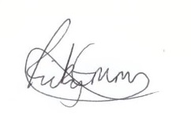

Ricky Emms

Head teacher