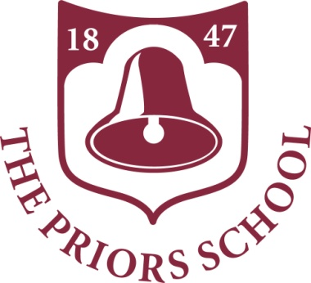

**Annual Report**

**to Parents**

**Child’s Name**

**End of Nursery Report**

**July 2022**

Dear Parents/Carers,

As we approach the end of the academic year, I am pleased to share with you your child’s annual report for 2021-22. This gives an overview of your child’s achievements this year, as well as some indications for their progress in the year ahead. I hope that you find its contents informative, and that you enjoy the opportunity to celebrate the progress made.

If you have any questions about the report, please do not hesitate to contact the school to make an appointment to discuss its content with your child’s class teacher.

*Ricky Emms*  
Head Teacher

**Insert photo of child here**

**Class Teacher’s Comment**

|  |
| --- |
|  |

|  |  |
| --- | --- |
| **Communication and Language** | |
|  | |
| On track / Working Towards |
| **Personal, Social and Emotional Development** | |
|  | |
| On track / Working Towards |
| **Physical Development** | |
|  | |
| On track / Working Towards |
| **Literacy** | |
|  | |
| On track / Working Towards |
| **Mathematics** | |
|  | |
| On track / Working Towards |
| **Understanding the World** | |
|  |
| On track / Working Towards |
| **Expressive Arts and Design** | |
|  | |
| On track / Working Towards |

|  |  |  |  |
| --- | --- | --- | --- |
| **Targets** | | | |
|  | | | |
| Key Person’s Signature |  | Date |  |

Child says…

My headteacher says…

Signed:

Date:

My parents/guardians say…

Signed:

Date: